FOLDER: DATA/ Variables_Europe

FILE: Urban areas.shp

Description: spatial polygon dataframe.

* Scripts: 3_Environmental variables, 3B_Subset_environmental_DEU_CZ_and_POL
* Output: plots and urban_areas_three.shp

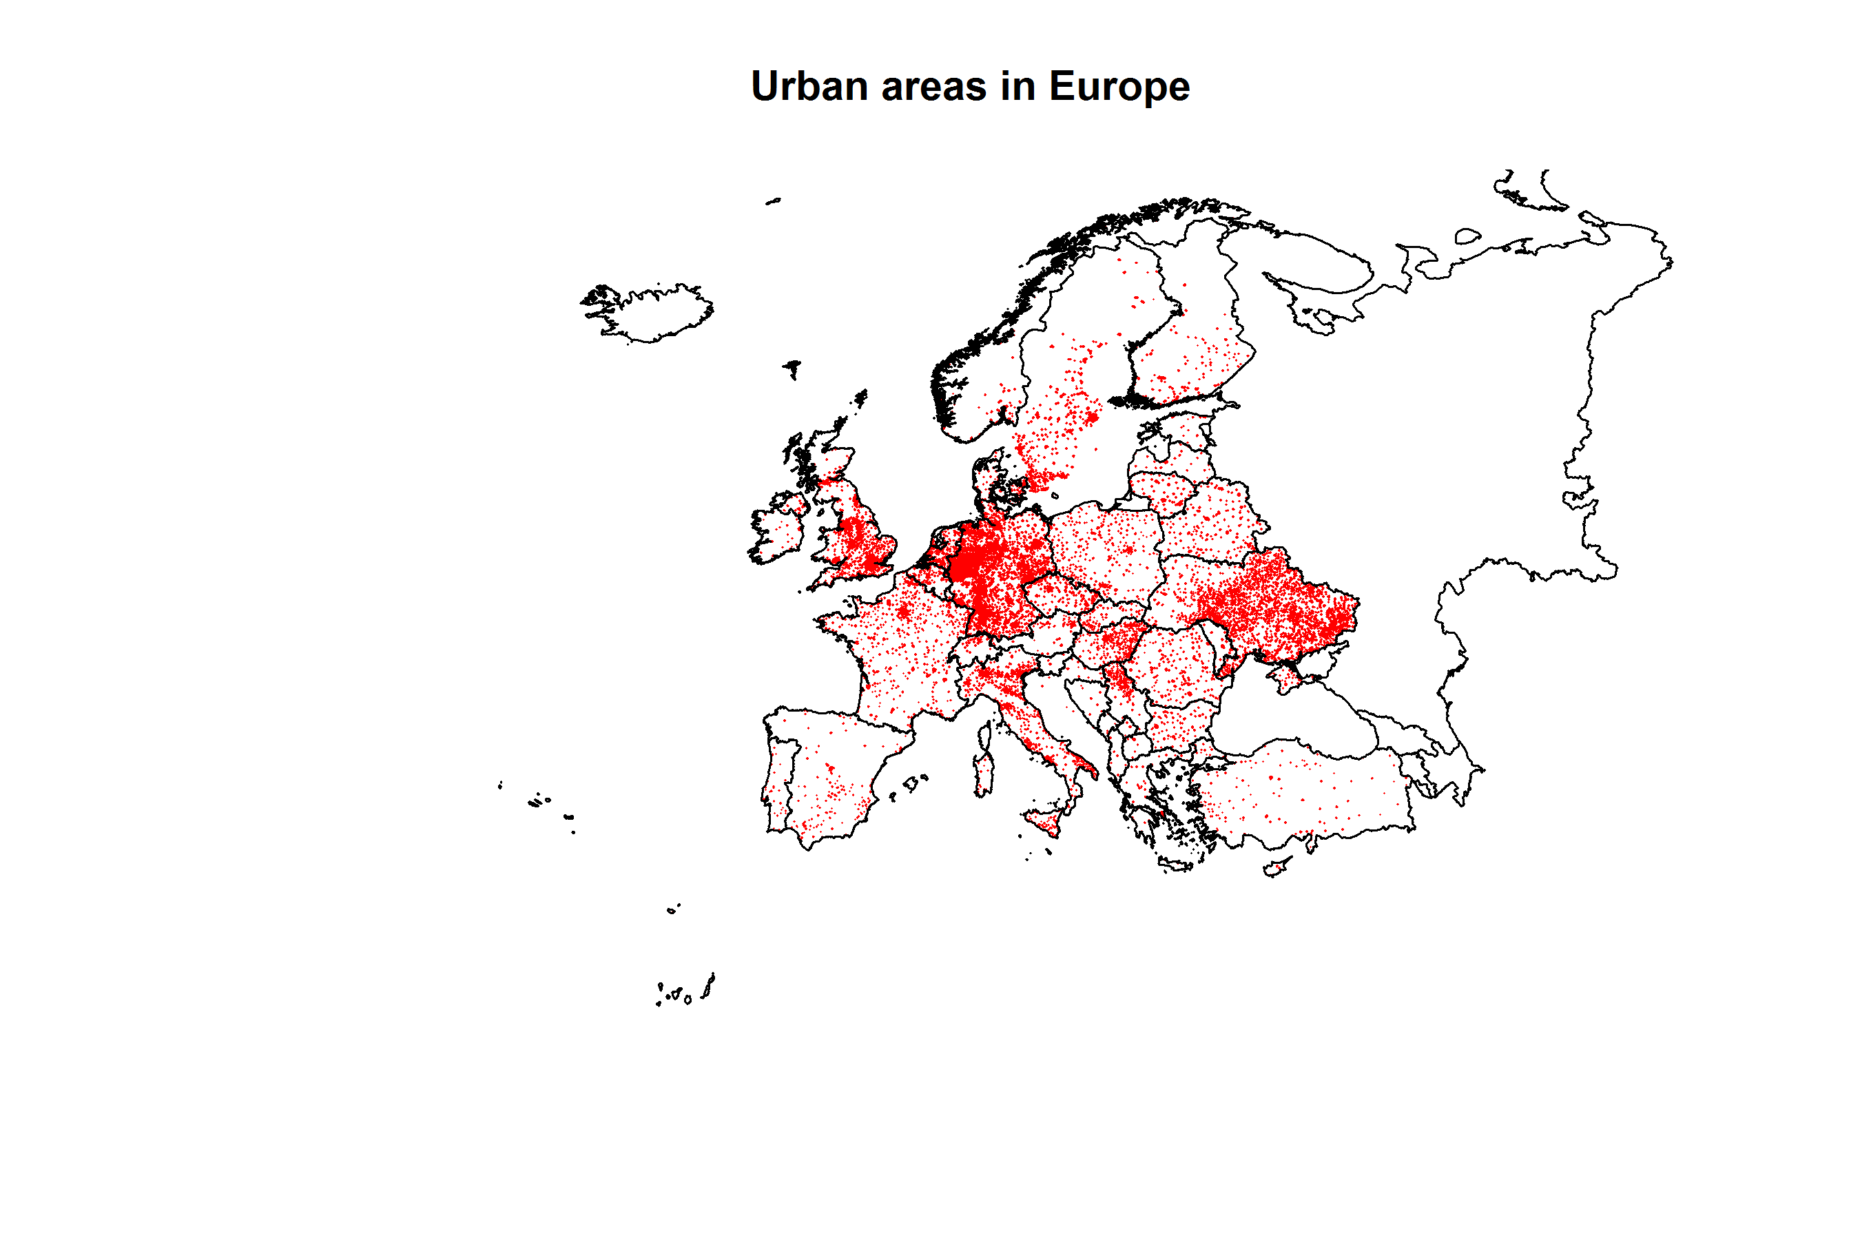

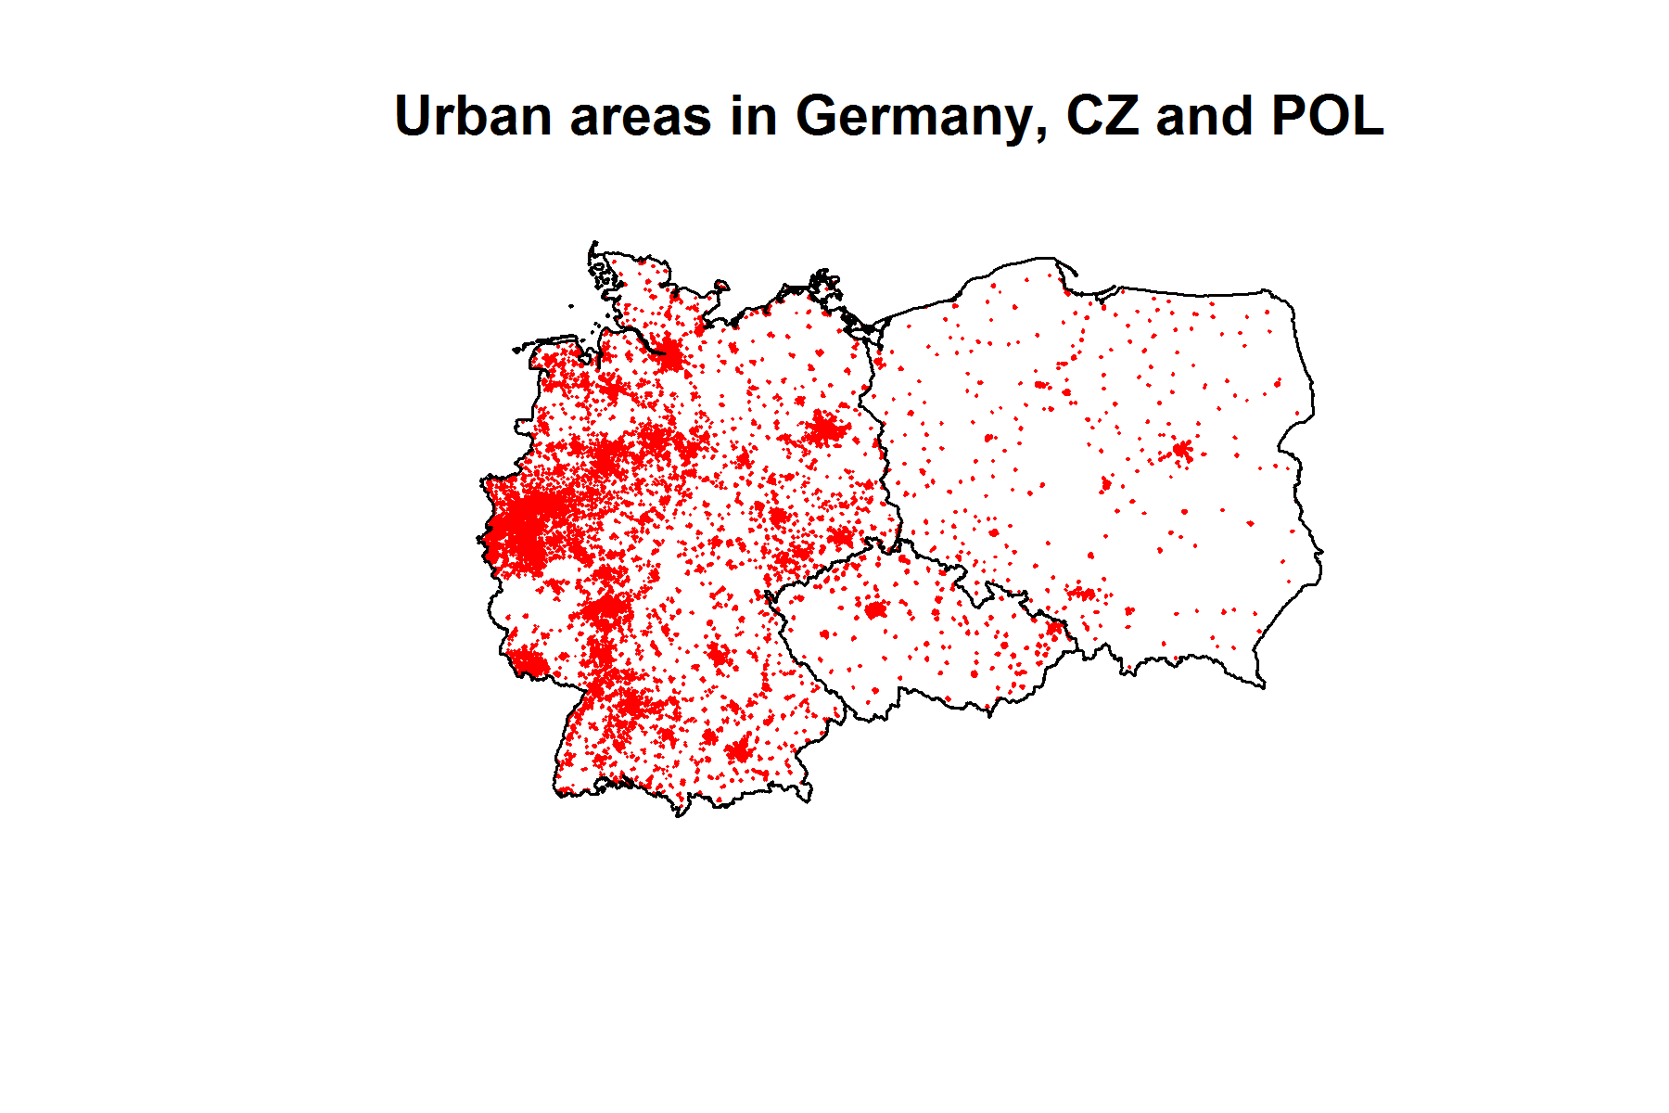

FILE: Lakes_large.shp

Description: spatial polygon dataframe.

* Scripts: 3_Environmental variables, 3B_Subset_environmental_DEU_CZ_and_POL
* Output: plots and lakes_large_three.shp

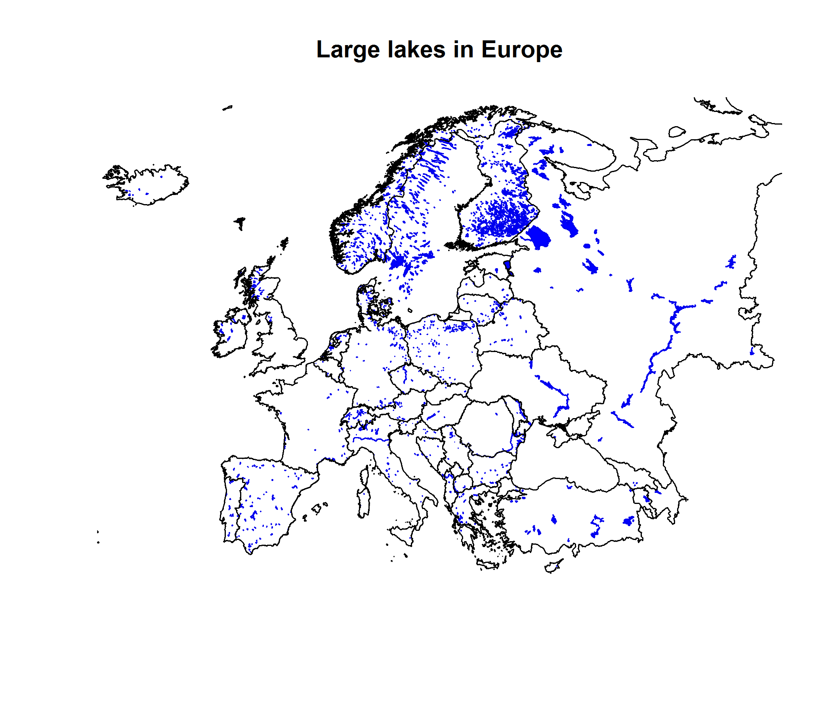

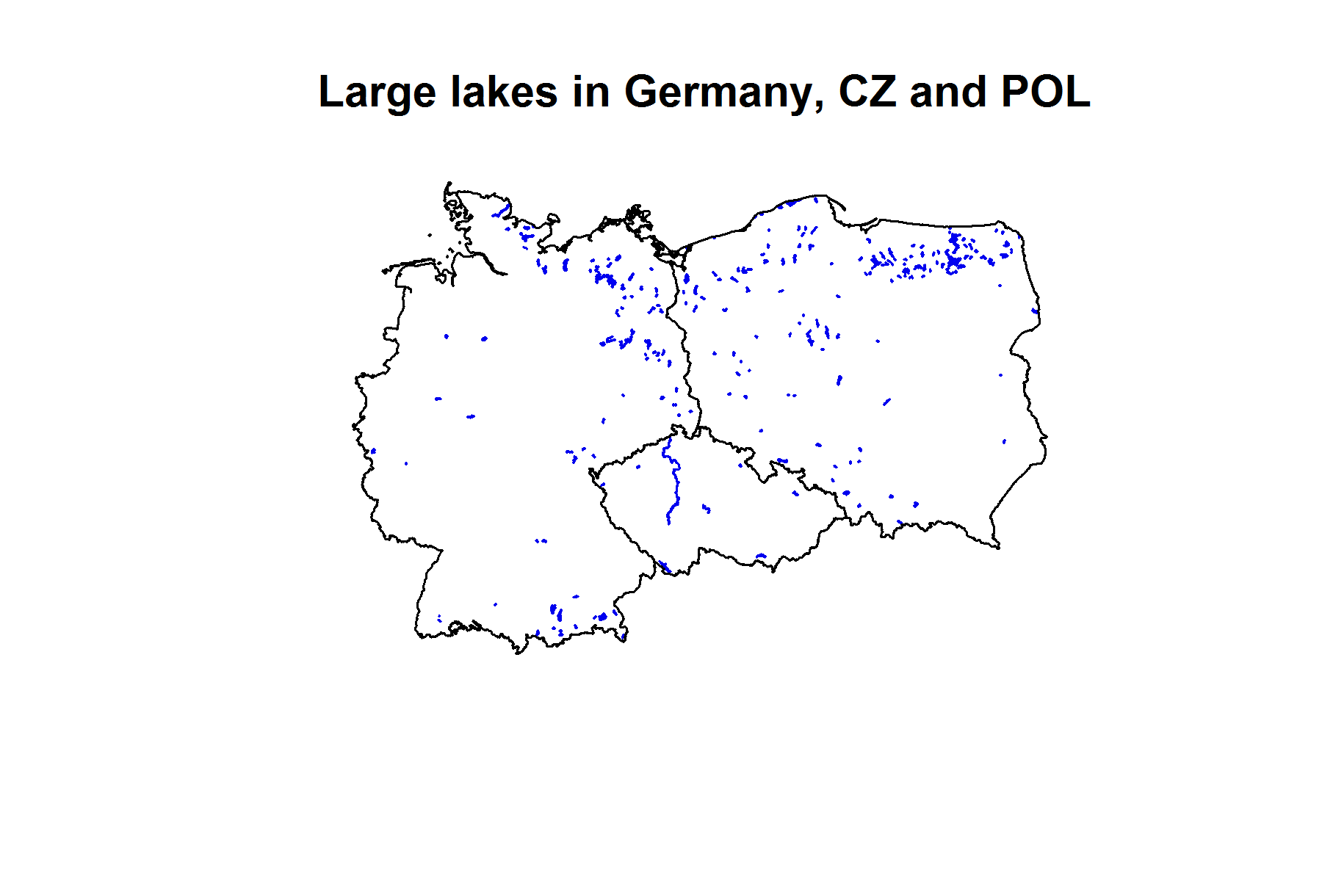

FILE: Rivers.shp

Description: spatial lines dataframe.

* Scripts: 3_Environmental variables, 3B_Subset_environmental_DEU_CZ_and_POL
* Output: plots, rivers_large.shp and rivers_large_three.shp

All rivers in Europe

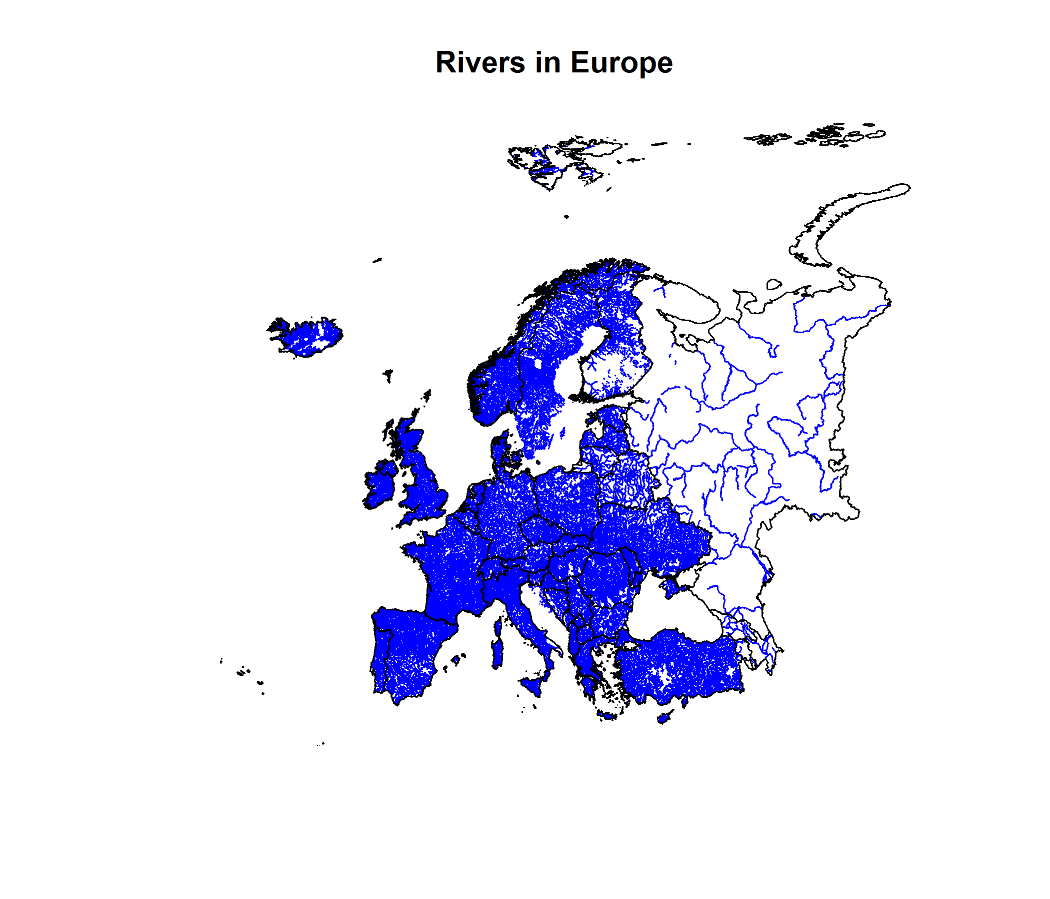

Only large rivers over 100 km in Europe

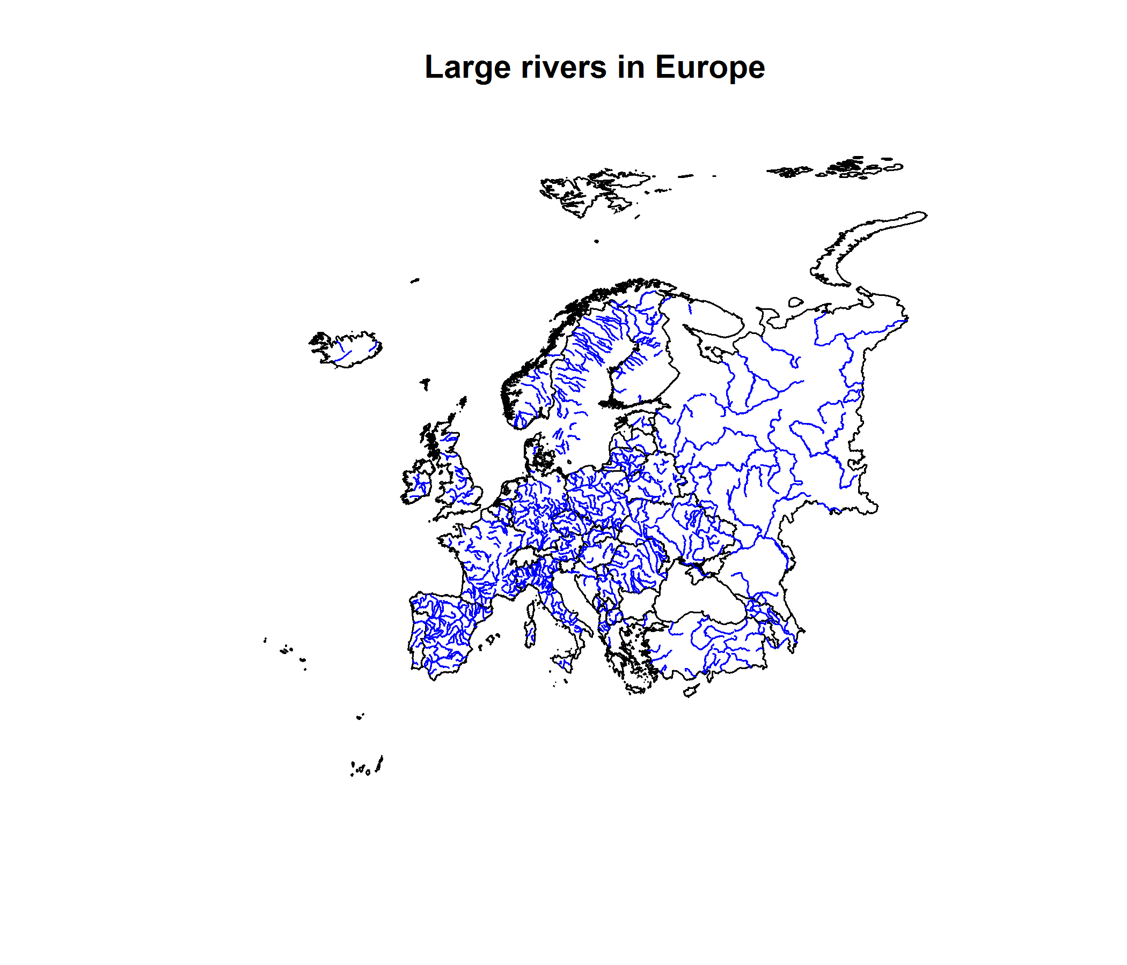

Only rivers over 100 km in Germany, Czech Rep or Poland

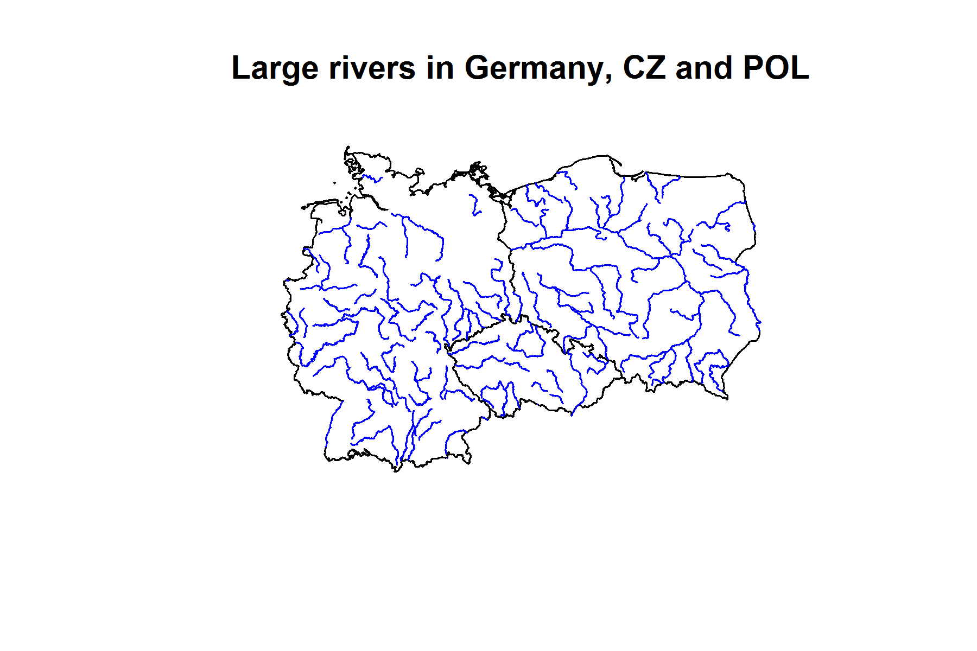

FOLDER: DATA/ Raster/Europe_altitude

FILE: Europe_altitude.shp

Description: spatial polygon dataframe.

* Scripts: 3_Environmental variables, 3B_Subset_environmental_DEU_CZ_and_POL
* Output: plots, altitude_raster and altitude_raster files for Europe and three selected countries, respectively

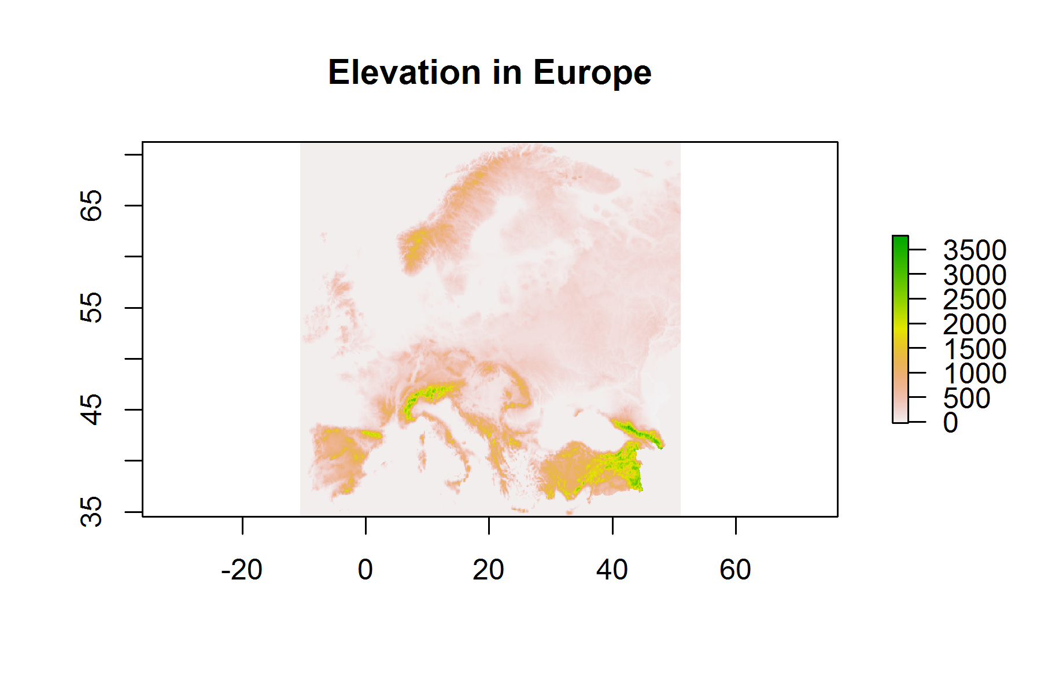

**Elevation in Germany, Poland and Czech Republic**

